PROJECT

STUDENT FEEDBACK SYSTEM

Note I implement only my usecase

Mustafa sp23-bse-067

### ****Overview****

A **modern web desktop application** that allows students to submit feedback about courses and teachers, while faculty and admins can view and analyze feedback reports.

### ****Key Features****

✔ **User Roles** (Student, Teacher, Admin) with different dashboards  
✔ **Secure Login** with password authentication  
✔ **Feedback Submission** with ratings (1-5) and comments  
✔ **Responsive GUI** with a web-like attractive interface  
✔ **Database Integration** (MySQL) for storing users and feedback  
✔

### ****Tech Stack****

**Frontend**: html css javascript react (for modern UI components)

**Backend**: node js (JDBC for database connectivity)

**Database**: MySQL (stores user accounts and feedback)

**Security**: Password hashing (basic implementation

**Note Click on the chapter name to check diagram**

Student Feedback System - General Components 1

1. User Roles 1

2. Core Features 1

3. Technical Requirements 1

4. Optional Enhancements 1

Chapter No 1 3

INTRODUCTION 3

Student Feedback System - General Components 3

1. User Roles 3

2. Core Features 3

3. Technical Requirements 4

4. Optional Enhancements 4

Chapter 2 4

Usecase1 4

4

Mustafa Sp23bse-067 5

6

Chapter 3 7

Fully addressed 7

7

Mustafa kamal sp23-bse-067 8

10

Chapter 4 11

SSD 11

11

Mustafa sp23-bse-067 12

12

Chapter 5 13

Class diagram 13

13

MUSTAFA SP23-BSE-067 14

15

Chapter 6 16

Communication diagram 16

16

Mustafa sp23-bse-067 17

17

# 

# Chapter No 1

## INTRODUCTION

# ****Student Feedback System - General Components****

### ****1. User Roles****

**Students** – Submit feedback on courses/teachers.

**Teachers/Faculty** – View feedback reports

**Admin** – Manages users & system settings

### ****2. Core Features****

**Authentication** (Login/Signup for students & faculty).

**Feedback Submission Form** (Ratings + Comments).

**Dashboard** (View feedback analytics for teachers/admins).

**Admin Panel** (User management, feedback moderation).

### ****3. Technical Requirements****

**Frontend**: React(for modern UI components)

**Backend**: node js (JDBC for database connectivity)

**Database**: MySQL (stores user accounts and feedback)

**Security**: Password hashing (basic implementation)

### ****4. Optional Enhancements****

Email notifications (feedback submission/updates).

Charts/Graphs for feedback visualization.

Anonymous feedback option.

This system automates feedback collection and analysis for educational institutions

Chapter 2

## I cover two usecase there is no my team member usecase here

### Mustafa Sp23bse-067

**Register**

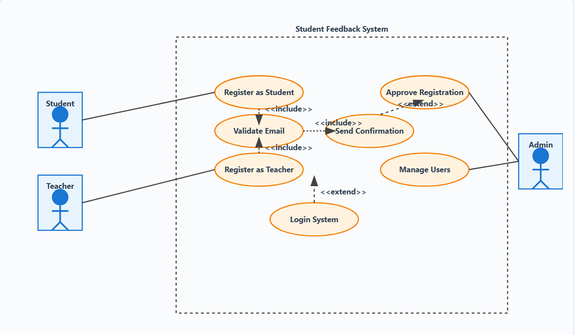

Login

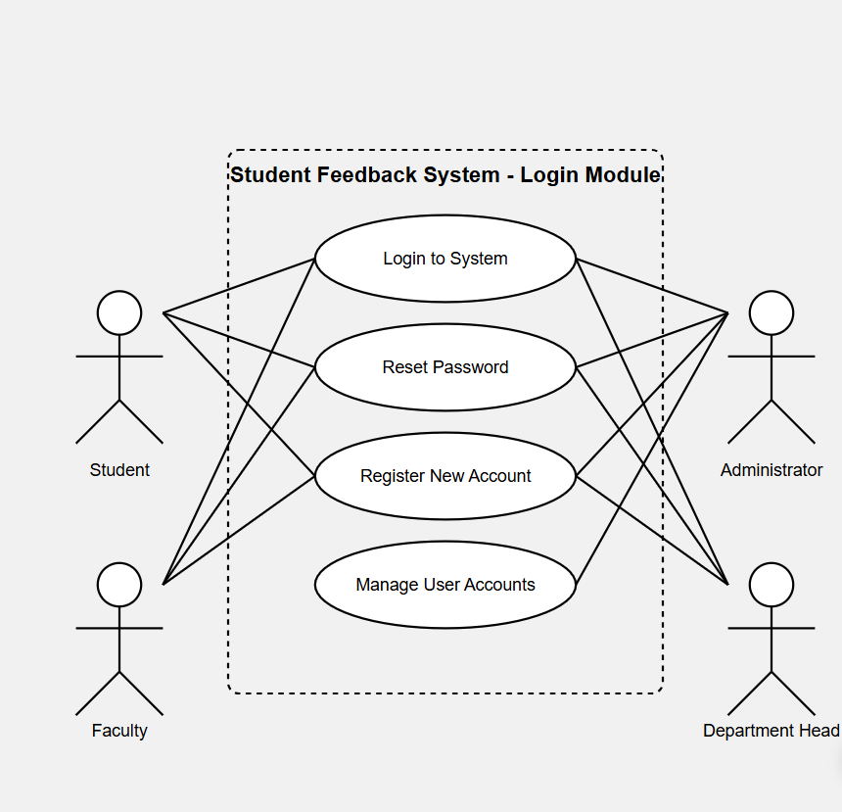

# 

# Chapter 3

## Fully addressed

### Register and login has almost same fullyaddressed so I make 1

### Mustafa kamal sp23-bse-067

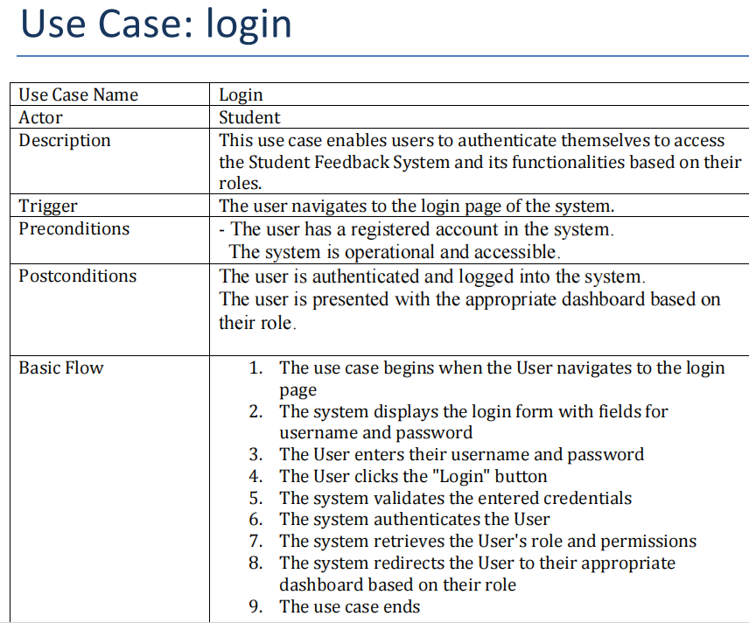

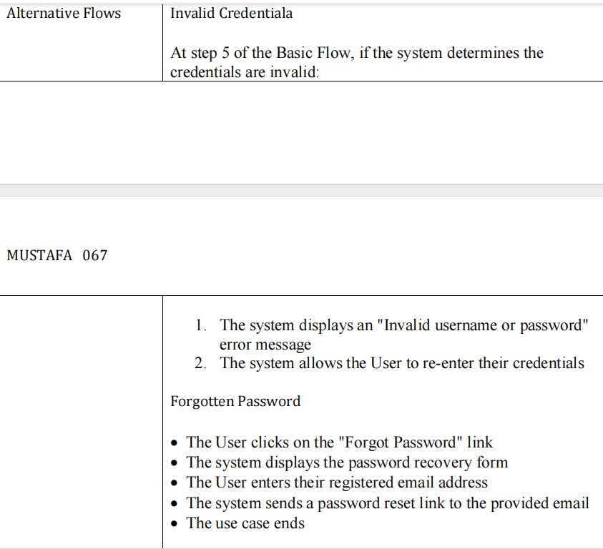

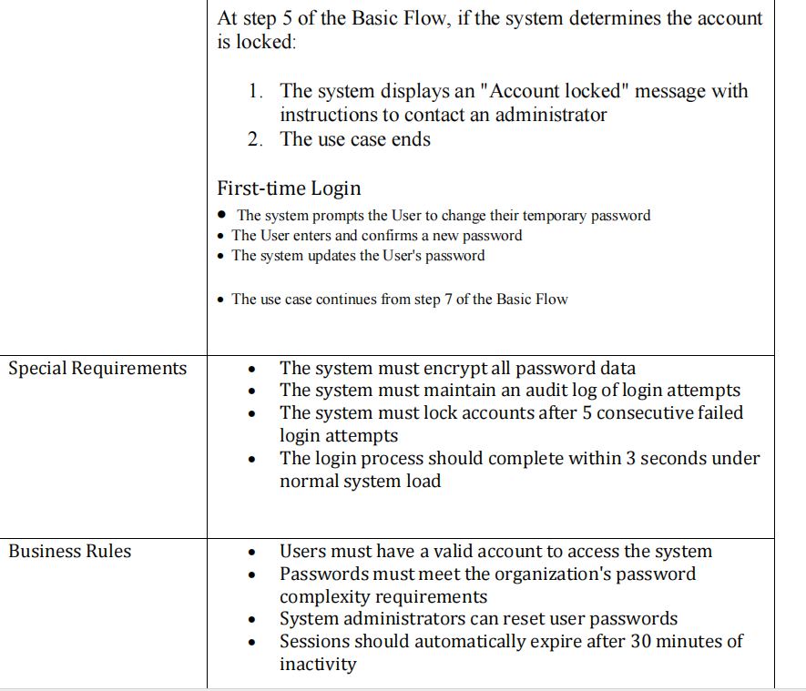

# Chapter 4

## SSD Register

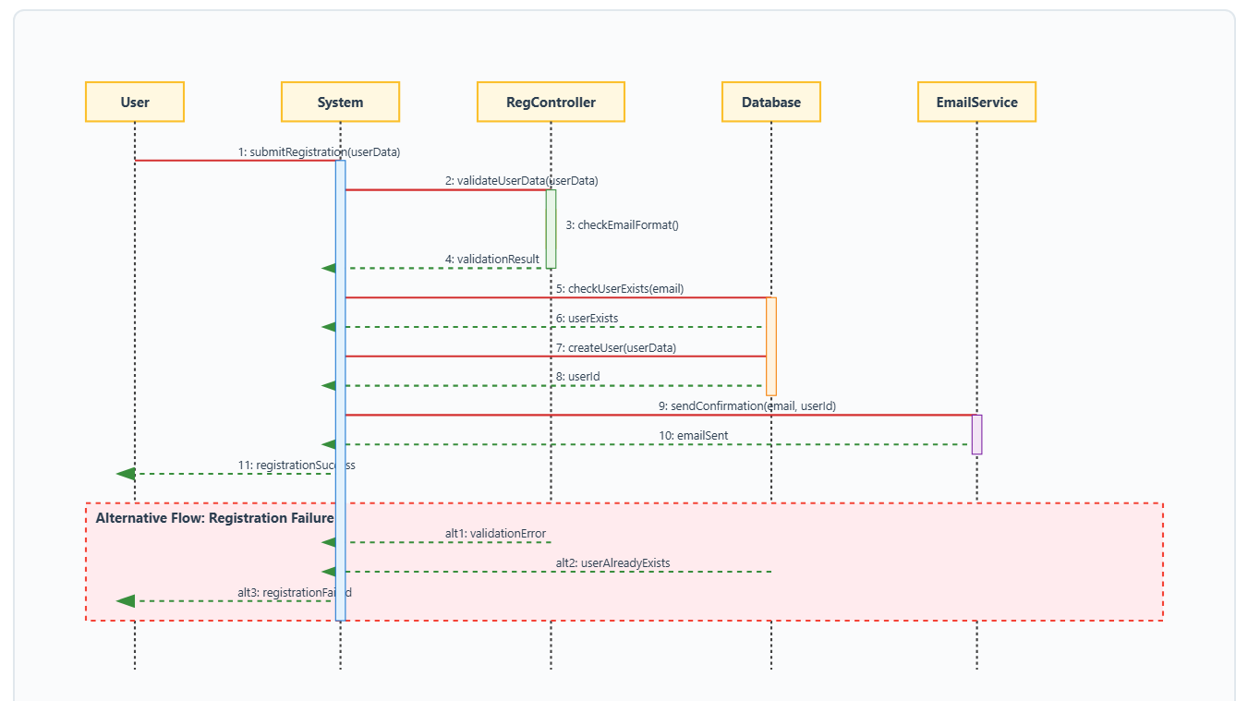

### Mustafa sp23-bse-067

**Login**

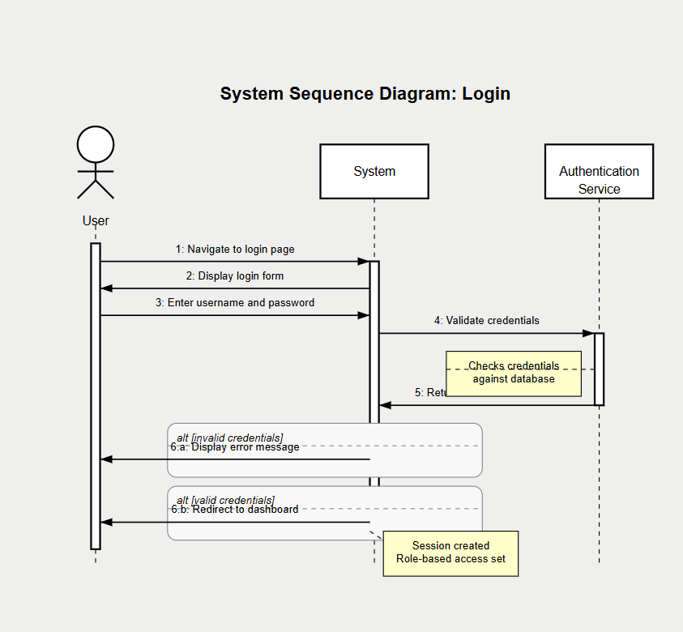

### 

# Chapter 5

## Class diagram

Register

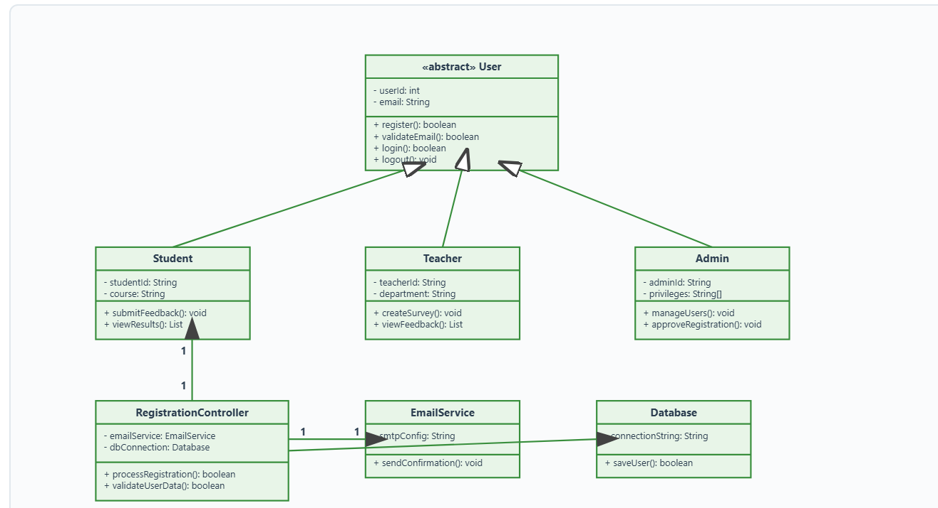

### MUSTAFA SP23-BSE-067

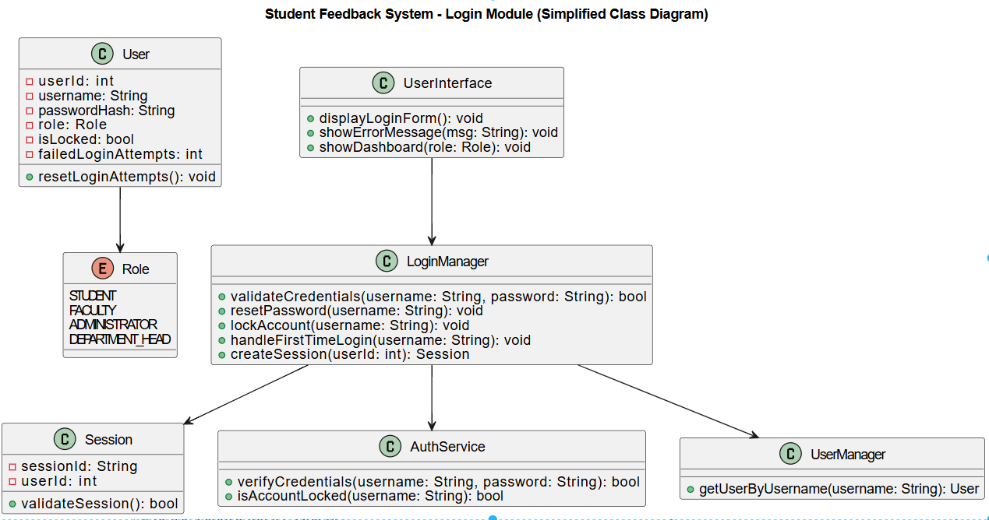

# 

# Chapter 6

## Communication diagram

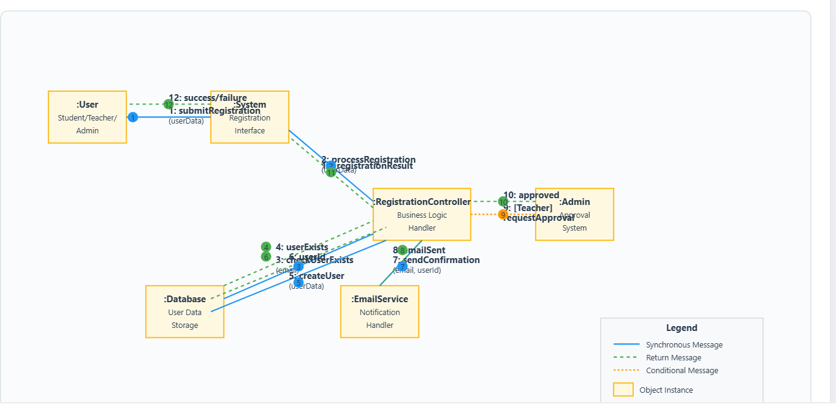

### Mustafa sp23-bse-067

